Grove - Sound Sensor

(Redirected from [Twig - Sound Sensor](http://www.seeedstudio.com/wiki/index.php?title=Twig_-_Sound_Sensor&redirect=no))

|  |
| --- |
| **Contents**   [[hide](javascript:toggleToc())]   * [1 Introduction](http://www.seeedstudio.com/wiki/index.php?title=Twig_-_Sound_Sensor#Introduction) * [2 Features](http://www.seeedstudio.com/wiki/index.php?title=Twig_-_Sound_Sensor#Features) * [3 Applications Ideas](http://www.seeedstudio.com/wiki/index.php?title=Twig_-_Sound_Sensor#Applications_Ideas) * [4 Specification](http://www.seeedstudio.com/wiki/index.php?title=Twig_-_Sound_Sensor#Specification) * [5 Usage](http://www.seeedstudio.com/wiki/index.php?title=Twig_-_Sound_Sensor#Usage) * [6 Version Tracker](http://www.seeedstudio.com/wiki/index.php?title=Twig_-_Sound_Sensor#Version_Tracker) * [7 Resources](http://www.seeedstudio.com/wiki/index.php?title=Twig_-_Sound_Sensor#Resources) * [8 Support](http://www.seeedstudio.com/wiki/index.php?title=Twig_-_Sound_Sensor#Support) |

Introduction 

The Sound sensor module is a simple microphone. Based on the power amplifier LM386 and the electret microphone, it can be used to detect the sound strength of the environment. The value of output can be adjusted by the potentiometer.

Model:[SEN12945P](http://www.seeedstudio.com/depot/-p-752.html?cPath=144_148)

[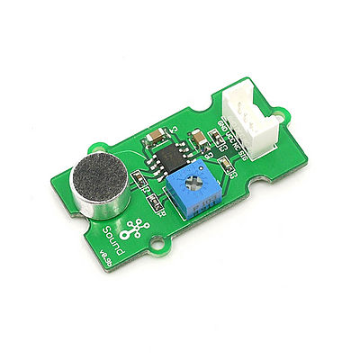](http://www.seeedstudio.com/wiki/File:Twig-Sound-sensor.jpg)

Features

* Grove compatible interface
* Wide supply voltage range
* Low quiescent current
* Gain adjustable

Applications Ideas

* Simple microphone
* Sound detection

Specification

|  |  |  |  |  |  |
| --- | --- | --- | --- | --- | --- |
| **Items** | **Conditions** | **Min** | **Type** | **Max** | **Unit** |
| VCC | - | 4 | 5 | 12 | V |
| Supply Current | V cc= 5V | - | 4 | 8 | mA |
| Voltage Gain (A ) | V S= 6V, f = 1 kHz | - | 26 | - | dB |
| Microphone sensitivity | 1KHZ | -52 | - | -48 | dB |
| Microphone Impedance | - | - | 2.2 | - | KΩ |
| Microphone Frequency | - | 20 | - | 16K | HZ |
| Microphone S/N ratio | - | - | 54 | - | dB |
| Microphone Sensitivity Reduction | 4.5V-3.0V | - | - | 3 | dB |

Usage

This module uses the LM386 power amplifier to strengthen the electronic signal produced by the electret microphone. When powered on ,the SIG pin will output the signal regulated by LM386. The potentiometer at the output can be used to regulate the gain.

The following sketch demonstrates a simple application of the sound sensor to control the led. As the picture on the below indicates, the Sound sensor is connected to analog port A0 of the [Grove - Basic Shield](http://www.seeedstudio.com/wiki/Grove_-_Base_Shield) and the LED to digital port 12. The potentiometer is used to regulate the gain of the output signal. The larger the potentiometer, the larger the output signal. If the sound of the environment is bigger than the threshold, then the Led will be turned on.

[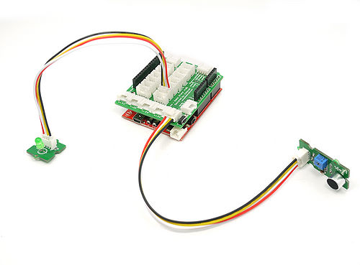](http://www.seeedstudio.com/wiki/File:Sound_LED.jpg)

* Then connect Arduino to PC by using a USB cable.
* Copy and paste code below to a new Arduino sketch.

// Function: If the sound sensor senses a sound that is up to the threshold you set in the code, the LED is on for 200ms.

// Hardware: Grove - Sound Sensor, Grove - LED

/*macro definitions of the sound sensor and the LED*/

#define SOUND_SENSOR A0

#define LED 3 // the number of the LED pin

#define THRESHOLD_VALUE 400//The threshold to turn the led on 400.00*5/1024 = 1.95v

void setup()

{

pins_init();

}

void loop()

{

int sensorValue = analogRead(SOUND_SENSOR);//use A0 to read the electrical signal

if(sensorValue > THRESHOLD_VALUE)

{

turnOnLED();//if the value read from A0 is larger than 400,then light the LED

delay(200);

}

turnOffLED();

}

void pins_init()

{

pinMode(LED, OUTPUT);

pinMode(SOUND_SENSOR, INPUT);

}

void turnOnLED()

{

digitalWrite(LED,HIGH);

}

void turnOffLED()

{

digitalWrite(LED,LOW);

}

* Upload the code, Please click [here](http://www.seeedstudio.com/wiki/Upload_Code) if you do not know how to upload.
* Then the LED light when the sound of the environment is bigger than the threshold. Have a try!

Version Tracker

|  |  |  |
| --- | --- | --- |
| **Revision** | **Descriptions** | **Release** |
| v0.9b | Initial public release | Jan 14, 2011 |

Resources

* [Grove - Sound Sensor Eagle files](http://garden.seeedstudio.com/images/6/6c/Sound_sensor_v0.9b.zip)
* [LM386pdf](http://garden.seeedstudio.com/images/a/ae/LM386.pdf)

s